**Ctrl+Click here to access the Membership Application**

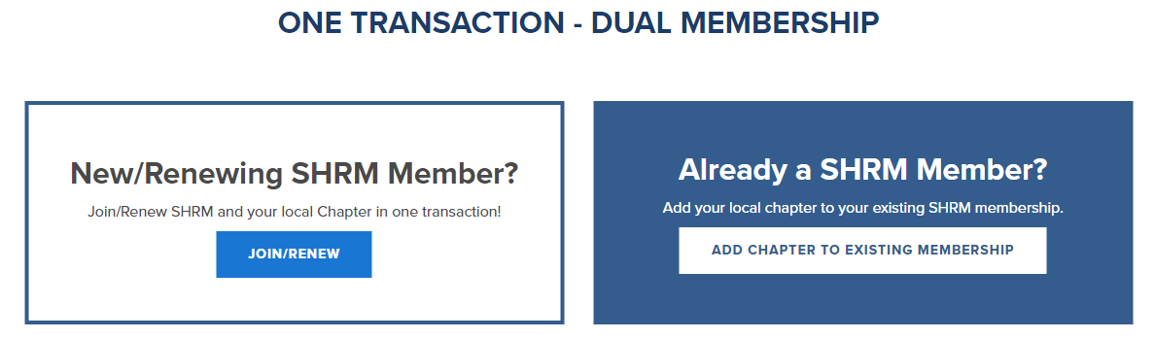

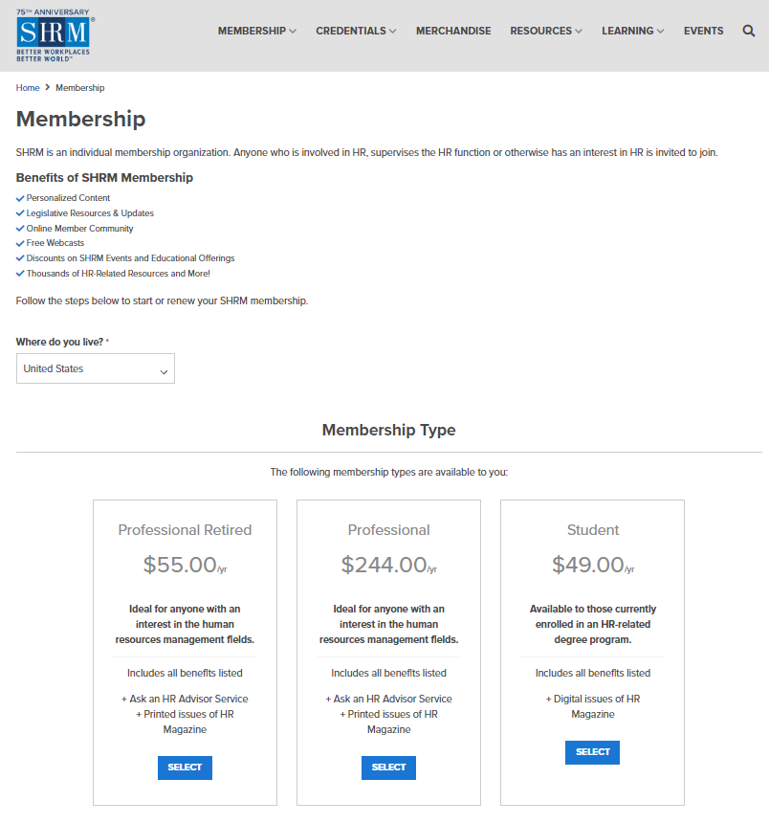

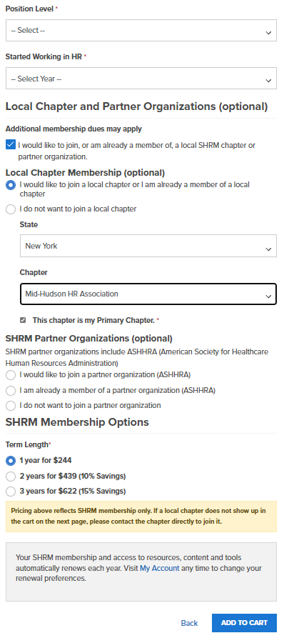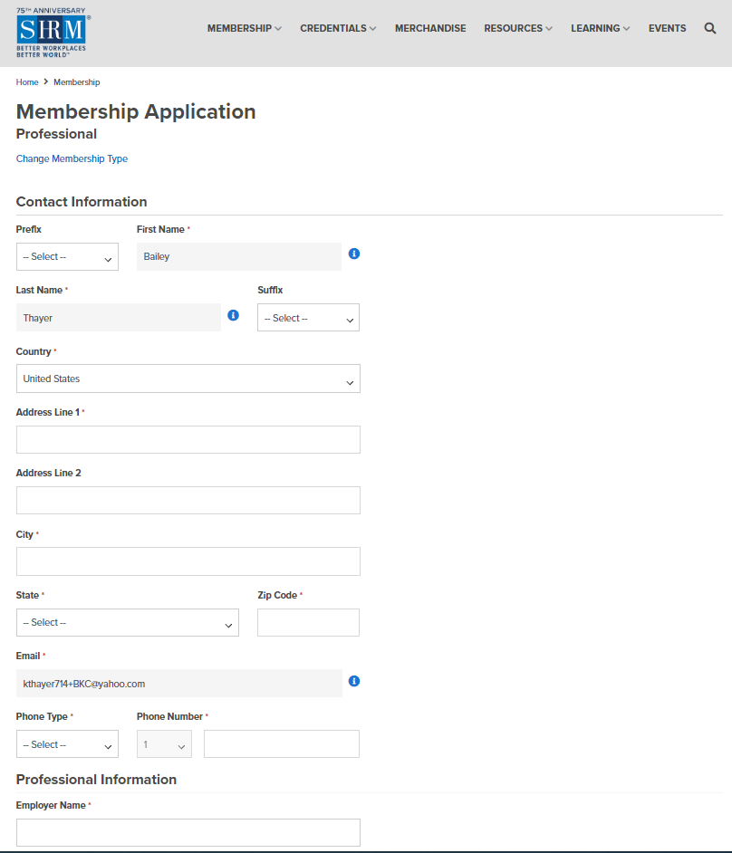

Click here to open the area below.

Pick

**“Mid-Hudson HR Association”**

Picking another chapter will not provide you with a **FREE** MHHRA membership.

This should be checked but if it isn’t, make sure to check it.